CREATE DATABASE
USE DATBASE
SHOW TABLES

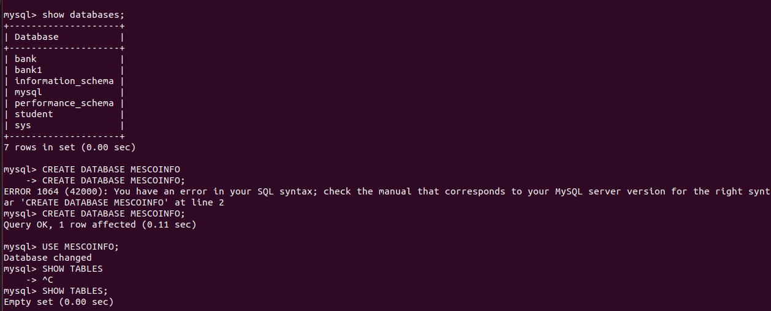

CREATE TABLE
INSERT INTO TABLE
UPDATE TABLE
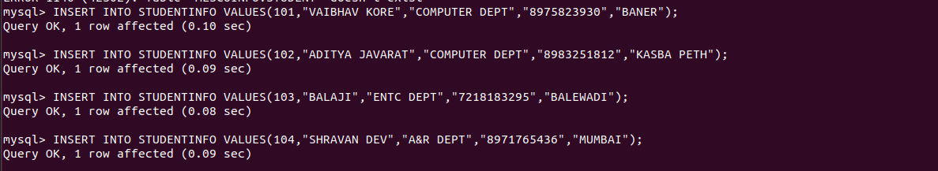
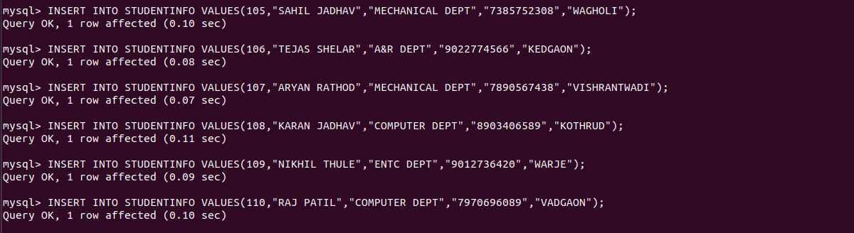

DESC TABLE
SELECT TABLE

